Submit online at https://proposalspace.com/calls/d/1497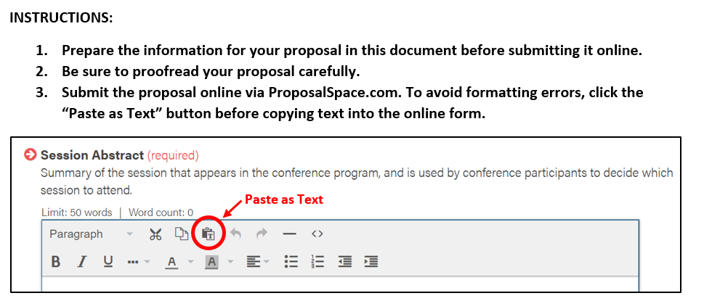
Presenters: For each presenter (up to four presenters total; presenters may not be added after proposal is accepte)
- Name:
- Affiliation:
- Email:
The Presenter/Organizer (the person filling out the proposal form) must also include their mailing address and telephone number, for MATSOL’s use only.

Session Title: Title of your presentation (required, 10 word maximum)

Abstract: Description for the conference program (required, 50 word maximum)

Session Description: Description for the proposal review – will not appear in the program
(4 parts, required) A description of the presentation that the proposal jury will read to select presentations for the conference. The Session Description does not appear in the program. Proposals undergo a double-blind review process so do NOT include your name or other identifying information.
- Topic & Purpose: Describe the topic and purpose of your proposed presentation. What is the focus of your presentation? Why is it relevant to today's EL educators? What educational need does your presentation fill? (150-250 words)

- Activities & Outcomes: Outline the sequence of activities that will take place during your session, including interactive activities such as break out rooms. List 1-3 specific outcomes of the session. (150 words maximum)

- Diversity, Equity & Inclusion: Provide additional explanation of how your proposed presentation will address racial justice and/or culturally responsive teaching (150 words maximum)

- Evidence Base: Describe how your proposal is grounded in relevant, current research and/or best practices. Cite sources using in-text citation (a list of works cited is not required). (150 words maximum)

Session Length: Choose one
- Regular: 45-minutes (IN-PERSON) / 60-minutes (ONLINE)
- Extended: 105-minutes (IN-PERSON) / 90-minutes (ONLINE)
Session Type: Choose one
- In-person presentation
- Online live presentation
- Either in-person or online
Topic Strands: Choose one topic strand related to PK-12 English Learner education that best suits your proposal. (required)
- Academic Language in the Content Areas
- Bilingualism and Biliteracy
- Co-Teaching and Collaborative Practices
- Culturally Responsive Teaching
- Curriculum Development
- Data and Assessment
- Digital Learning & Technology
- Family and Community Engagement
- Listening, Speaking and Pronunciation
- Policy and Advocacy
- Program Administration and Evaluation
- Professional Development and Teacher Education
- Reading, Writing and Literacy
- Vocabulary and Grammar
Audience: (required, choose one)
Choose the primary education sector addressed by your proposal. If the audience crosses sectors, choose “All Audiences.”
- All Audiences (PK12, adult and higher education)
- PK-12 Education
- Teacher Preparation/Education
- Adult ESOL
- Workplace ESOL
- Intensive English Programs (College/University)
- Community College ESL
- Private Language Schools
PK-12 Focus (optional, if applicable)
If your PK-12 Education proposal addresses specific grade levels, specify one or more.
- Early Education
- Grade PK-K
- Grade 1-3
- Grade 4-5
- Grade 6-8
- Grade 9-12

