Proposal Due Date: 11:59pm, Monday, December 2, 2019
Submit online at https://proposalspace.com/calls/d/1093 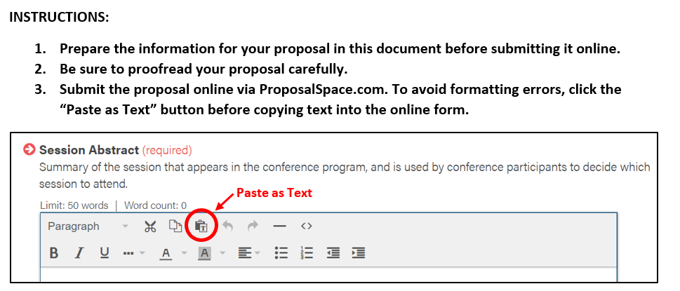
Presenters: For each presenter (up to four presenters total)
- Name:
- Affiliation:
- Email:

Session Title: Title of your presentation (required, 10 word maximum)

Abstract: Description for the conference program (required, 50 word maximum)

Session Description: Description for the proposal jury (required, 300 word maximum)

Citations: References for works cited in the Session Description (optional, 200 word maximum)

Session Type: Choose one (required)
- Practice-Oriented Presentation: (45 minutes)
- Interactive Workshop: (90 minutes)
- Informational Presentation (45 minutes)
- Discussion (45 minutes)
- Panel Presentation (45 minutes)

Topic Strand: Choose one topic strand related to PK-12 English Learner education that best suits your proposal. (required)
- Academic Language in the Content Areas
- Bilingualism and Biliteracy
- Co-Teaching and Collaborative Practices
- Culturally Responsive Teaching
- Curriculum Development
- Data and Assessment
- Listening, Speaking and Pronunciation
- Digital Learning & Technology
- Family and Community Engagement
- Policy and Advocacy
- Program Administration and Evaluation
- Professional Development and Teacher Education
- Reading, Writing and Literacy
- Vocabulary and Grammar

Primary & Secondary Audience: Choose up to TWO education sectors addressed by your proposal. (required)
- PK-12 Education
- Teacher Preparation/Education
- Adult ESOL
- Workplace ESOL
- University Intensive English Programs (IEPs)
- Community College ESOL
- Private Language Schools
PK-12 Focus: If applicable, specify one or more PK-12 educational contexts addressed by your proposal. (optional)
- Early Education
- Lower Elementary
- Upper Elementary
- Middle School
- High School

